Documentation
Thought Process
I could have easily mimicked some real-life data such as transactions or profits for a company, but I wanted to find something truly interesting to talk about.

After perusing Kaggle for hours, I found something that interested me. I found the latest statistics (that being of May 2024) for the most popular gaming streaming site Twitch. I may be too old or not enough into video games to spend my spare time watching other people play games, but I cannot deny the huge explosion in popularity this platform has received in the last couple years.

The effect Twitch has had on popular culture is undeniable, along with the complete domination of our youth, Twitch is something unbelievable, and through its analysis I hope to explain to you why it has so successful and what we can do help it become even more of a powerhouse in modern culture.

Everyone wants to become a Twitch streamer, with most popular streamer Kai Cenat creating a Streamers University, a huge event where hundreds of hopeful streamers would gather in lecture halls and learn about things (I honestly don’t know what they were talking about or even what the whole point is but anyway). In addition, there are a plethora of streamers doing IRL streams on Twitch, with them just doing normal daily tasks whilst carrying a camera around with them.

Anyway, now that I have explained how big of a deal this is, I would like to explain the second part of my analysis, which will use another data set on Kaggle, with slightly different tables and results, but in general similar data. However, this data was made in 2020. This can tie me perfectly to make some cross generational analysis, as the streaming world pre and post COVID can easily named as different generations, as the lockdown propelled the online world to levels never seen before, which I will try to explain using first a comparison of the two data sets, and then a more in-depth analysis of the more recent data set to explain.

Explanations of Dataset
Before loading these datasets, I wanted to make sure that the data was all good. The two datasets had quite a lot of differences, but all I wanted to do was to find out the difference between the years to show how much the sphere of streaming has changed.

First Dataset

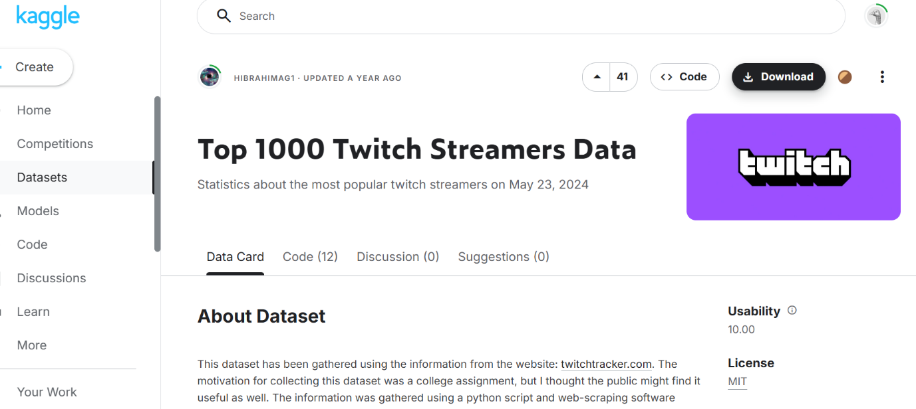
This dataset was made in May 2024, and will be the main document I will use to make my analysis. This document contained many important statistics such as Average Views per stream and other metrics that will be of interest for my analysis. Please be aware that both raw data files will be uploaded to the submission folder, so you will be able to access all of this.

Second Dataset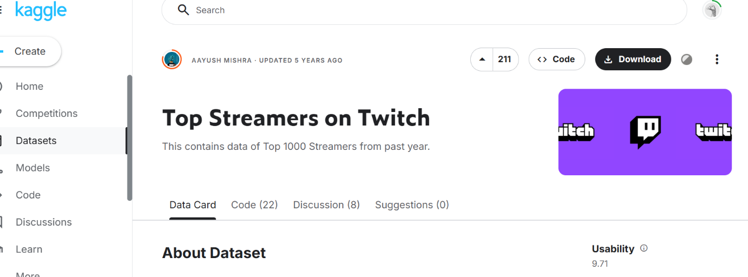
This dataset was published in March 2020, and will give me the information I need to compare the recent stats to the pre-covid ones to make my evaluations on the growth of the channel.

Pre Processing
However, I ran into some problems during the preprocessing and ingesting of data into Tableau. First, I knew I had to clean up the tables as there were many different columns in each table. I first aimed to create the exact same column names in each table, no matter if they were populated by nulls, just to be able to union them later in Tableau.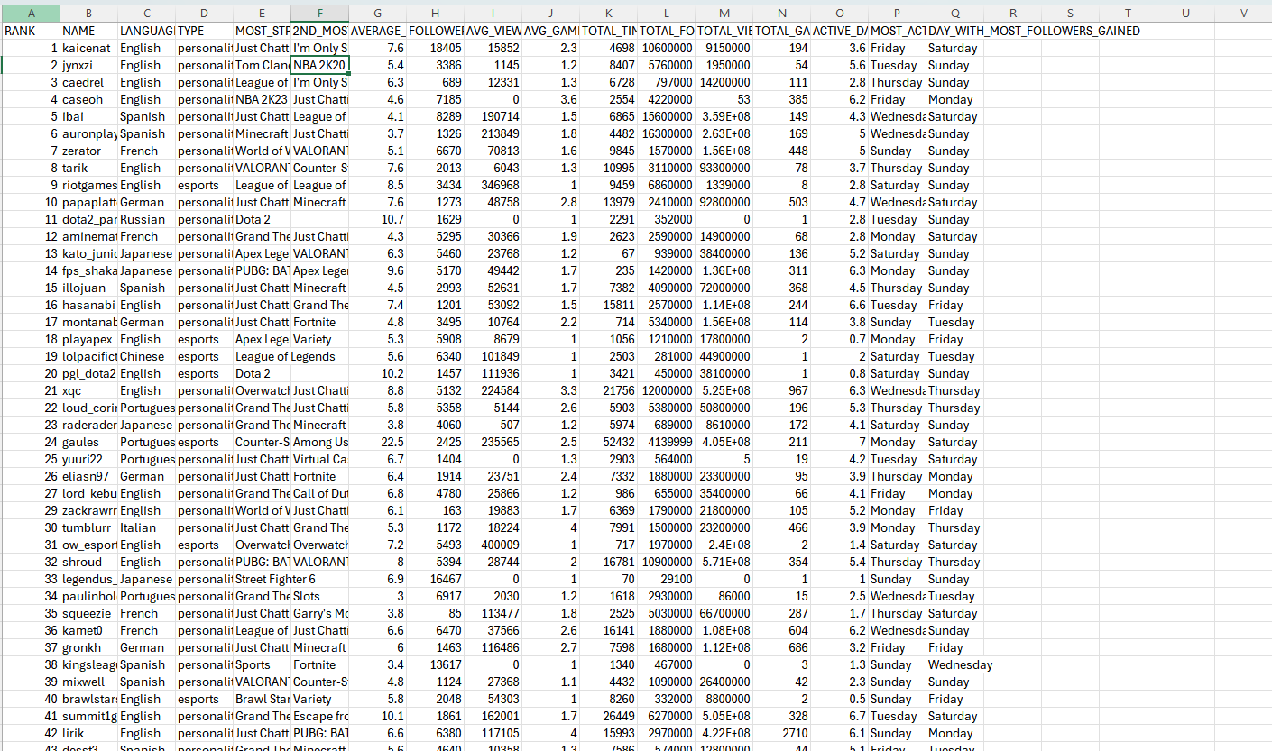
Here's an example of the 2024 data, I knew I had to convert it into a table and make sure all the table names were written in correct syntax.

Below is the raw data from 2020. You can see that a lot of the columns don’t match the previous table, so I had to make some executive decisions and cut out the data I felt did not match what I was trying to say, but most of it was cut out due to logistical problems of not being to join the tables.
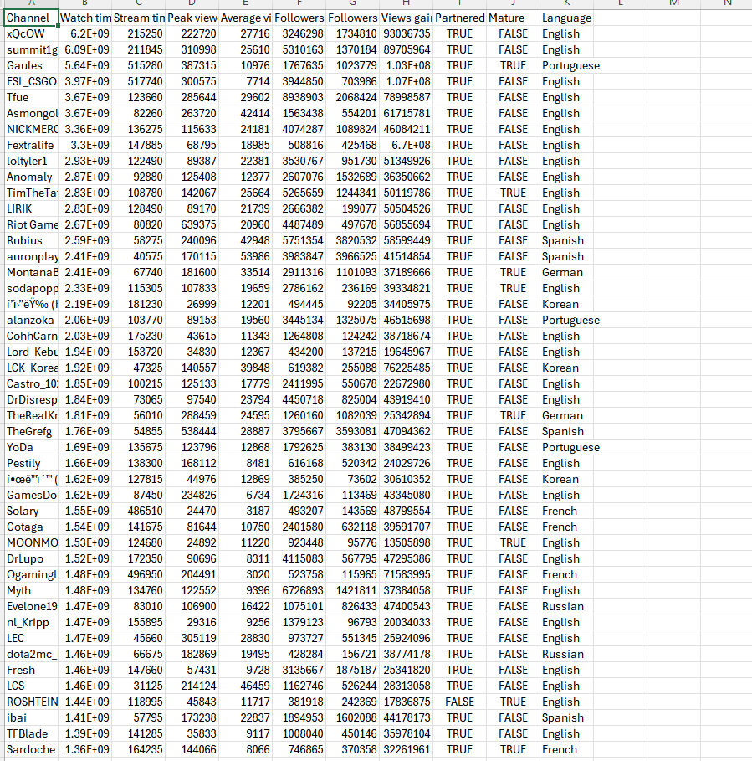

After imputing the same column names in both tables, I realised that for the 2020 document, there were too many discrepancies in the names of the streamers, be that due to human input error or because they didn’t stream on twitch anymore. Anyway, I decided to make it the top 50 streamers from 2020 to make life easier for myself, and it would not take away from the points I was trying to make.
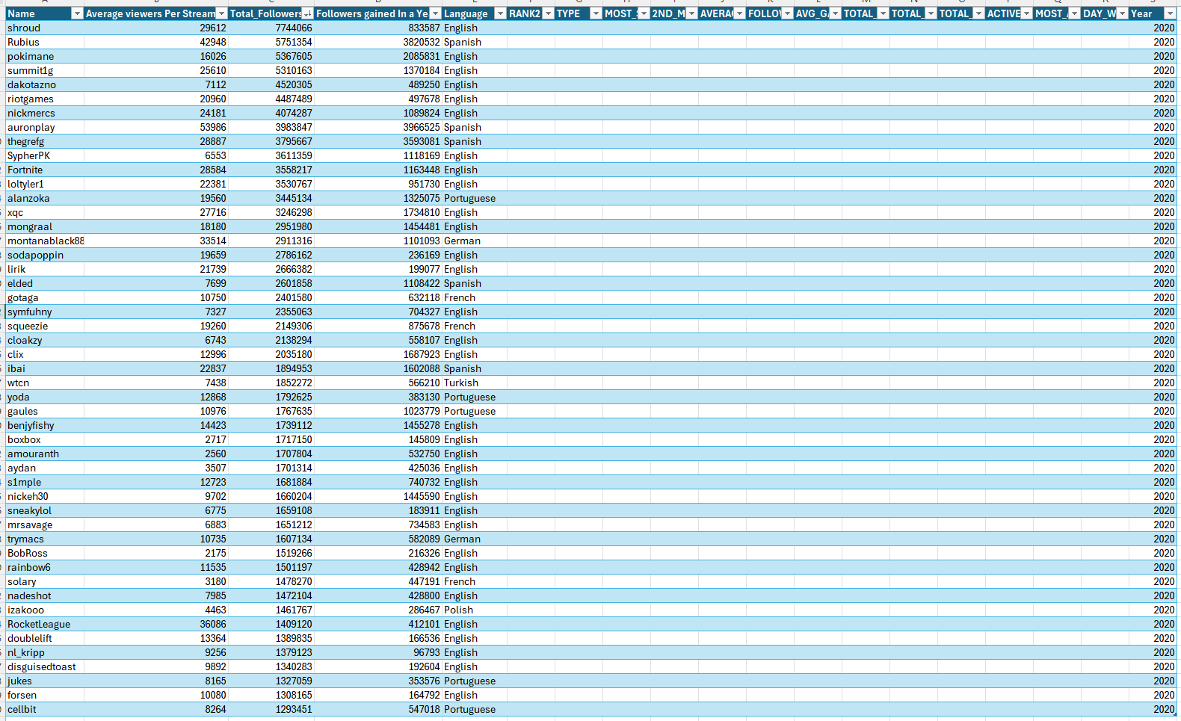
Here you can see the cleaned table of the top 50 streamers by subscribers in 2020. The columns with no information are the ones that I had to input to be able to union to the other table, as unfortunately this table either did not have enough interesting information or its format varied significantly that of 2024.

After getting both tables to have the same shape in terms of the columns, I went into Tableau to start my union and get on with the visualisations. However, I ran into a huge problem whilst trying to ingest my data. My data was not connecting, only through a join and that would cause my column names to double, making analysis impossible.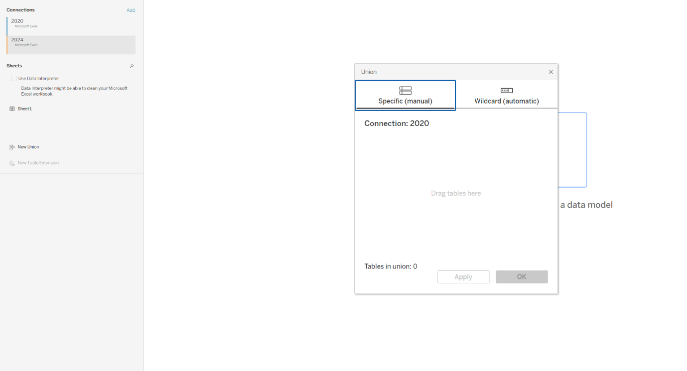
After many hours of trying everything, I nearly lost hope until Waseem the legend told me to try to put both sheets into one workbook, and this finally worked!
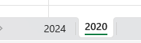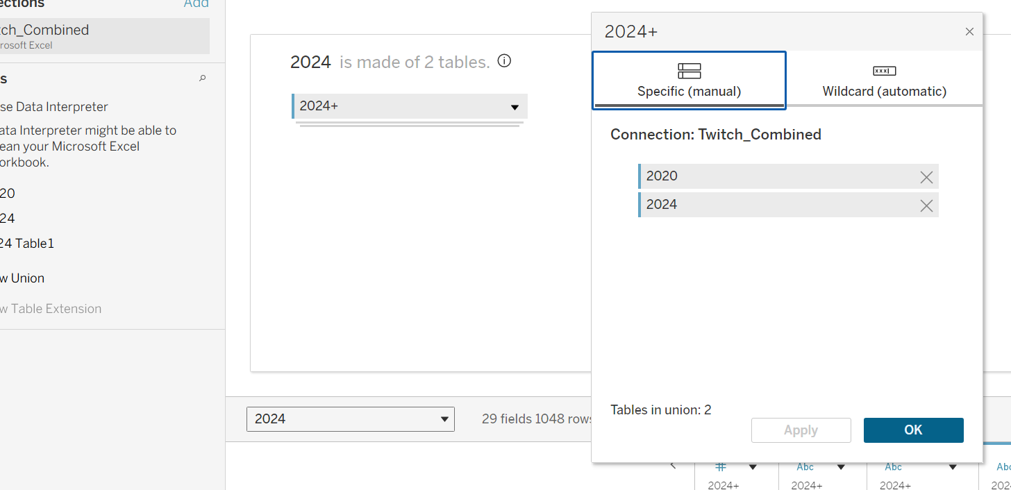

After all this gruesome work to connect my datasets, I finally managed to union my 2020 and 2024 files. Though a decent amount of the columns are populated with nulls, I was still able to reach the stage I wanted, which was to have a comparison of statistics from 2020 and 2024 to show growth. The fact that my 2020 document was not very populated did not matter to me, as its prime purpose was to provide me with evidence of a huge increase in popularity of Twitch from 2020 to 2024. The 2024 document however will be crucial for my analysis, as the information there will help me tell my story of why Twitch is doing so well, and how it transformed into cultural powerhouse it is today.

Just a quick note, all three of my documents that were mentioned in this document will me mentioned, that is; the raw 2020 file, the raw 2024 file and the combined Twitch file.

Thank you!

